Lab Objective

Implementing the infrastructure Servers

**Lab Procedures**

1. On Server01, continuing with the Remote Access Setup Configuration page, under Step 3, Infrastructure Server, click Configure. The Infrastructure Server Setup Wizard starts.

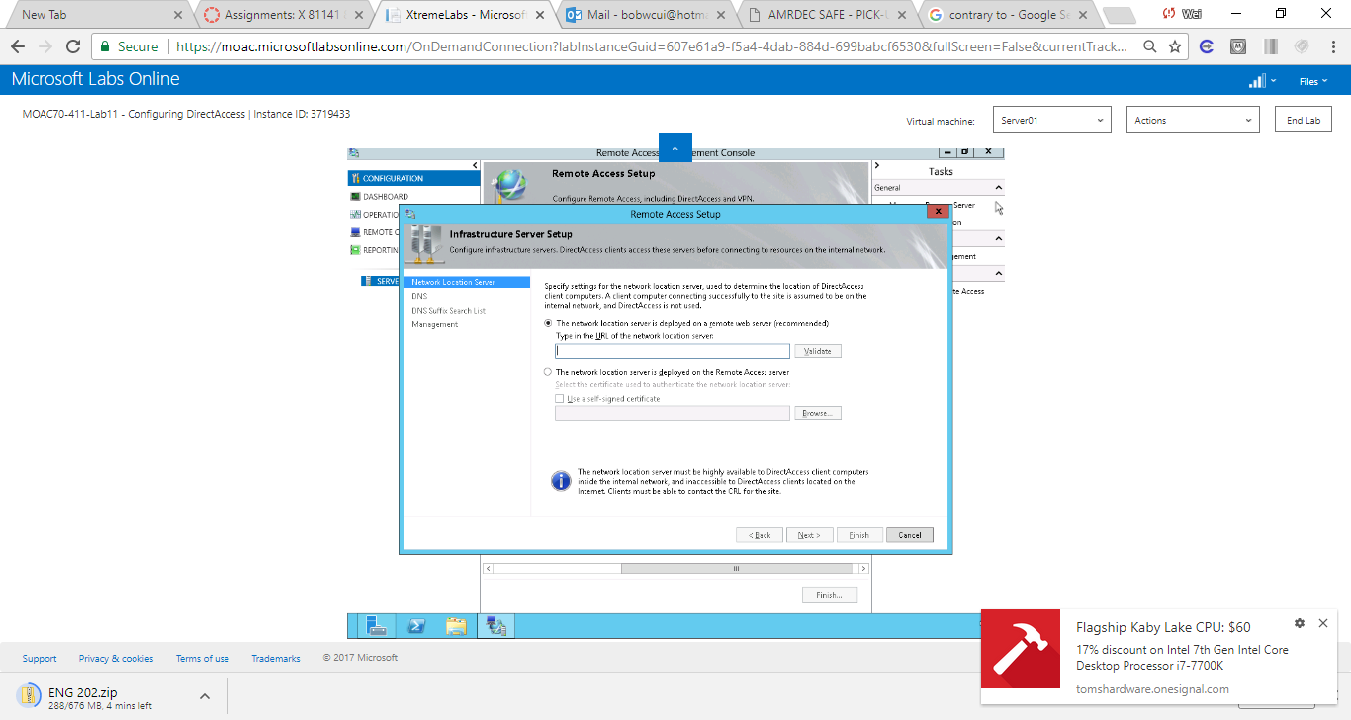

Figure On Server01, continuing with the Remote Access Setup Configuration page, under Step 3, Infrastructure Server, click Configure. The Infrastructure Server Setup Wizard starts

**2.** On the Network Location Server page, click *The network location server is deployed on the Remote Access server*. Click to select the *Use a self-signed certificate*.

**3.** Take a screen shot of the DNS Manager window by pressing Alt+Prt Scr and then paste it into your Lab11_worksheet file in the page provided by pressing Ctrl+V.

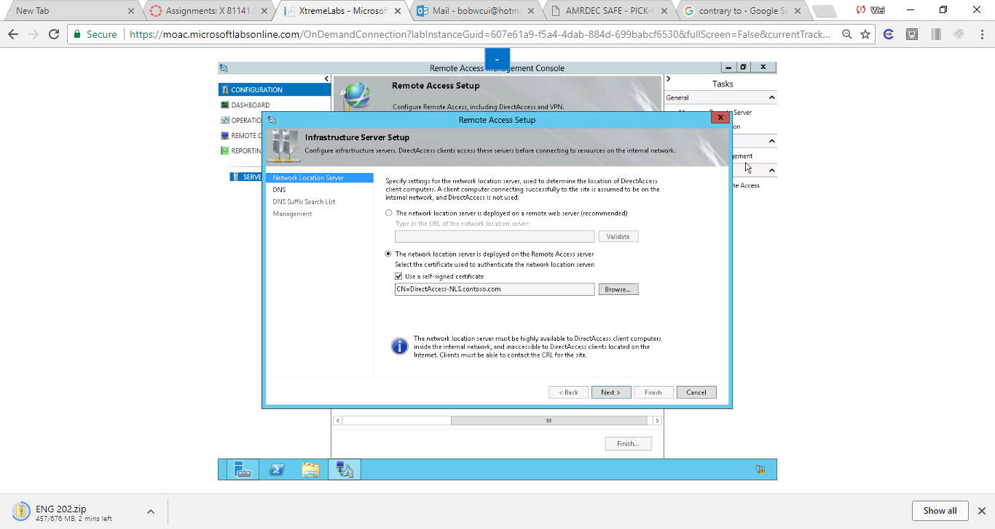

Figure On the Network Location Server page, click The network location server is deployed on the Remote Access server. Click to select the Use a self-signed certificate.

**4.** Click Next.

**5.** On the DNS page, click Next.

**6.** On the DNS Suffix Search List page, click Next.

**7.** On the Management page, double-click the first line of the Management Servers box to open the Add a Management Server dialog box.

|  |  |
| --- | --- |
| Question 3 | Which management servers would you include?  rwdc01.contoso.com |

**8.** In the Computer name text box, type **rwdc01.contoso.com** and click OK.

**9.** Click Finish.

**10.** Keep Remote Access Management console open for the next exercise.

End of exercise. You can leave the windows open for the next exercise.

**Lab Summary**

During this exercise, I performed Step 3 of the Run the Remote Access Setup Wizard, where I specified the infrastructure servers that are necessary for DirectAccess to function properly. In this exercise, the function of the Network Location Server is to detect whether computers configured as DirectAccess clients are located in the corporate network. The client resolves name requests using the DNS servers configured on its network interface settings. The client is able to connect to a domain controller, and the Domain Profile is applied.